**USER MANUAL FOR GAZE ANALYSIS (Sequence Path and Fixation)**

# [Prerequisite](https://www.merriam-webster.com/dictionary/prerequisite)

Python recommend version is 3.5 or above and the following Libraries

## Install the required libraries

* pip install pandas
* pip install numpy
* pip install matplotlib

## You must have gaze data collected through any eye-tracker for specific stimuli (Image).

* Check the sample file (eyetracker_data.csv) in folder (analysis ->data)

# Execute the Gaze Analysis- Eye Tracker

* The Eye-tracker gaze analysis folder contains two folder-
  + library folder (gazeanalyser), which is actual eye-tracker analysis module
  + Example code, how to use and execute the gazeanalyser module for generating eye-tracker analytics such as Sequence Path and Fixation plots on stimuli based on eye-tracker gaze data.

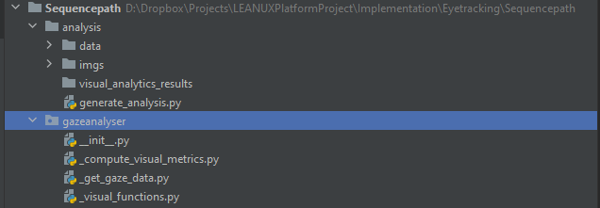



* In order to run the example code run th­e generate_analysis.py using command prompt or using any IDE such as pycharm.
  + python generate_analysis.py
* once you run the generate_analysis.py file then it will generate files under the folder of “visual_analytics_results” folder”

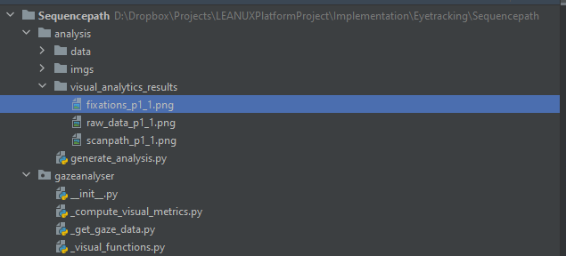



This is stimuli image.



Results:

* + This is raw points of gaze data on stimuli image.



* + This is Fixation map generated on stimuli image based on gaze data.



* + This is Sequence map of gaze data on stimuli image



* you can change data and stimuli image in generate_analysis.py

­­­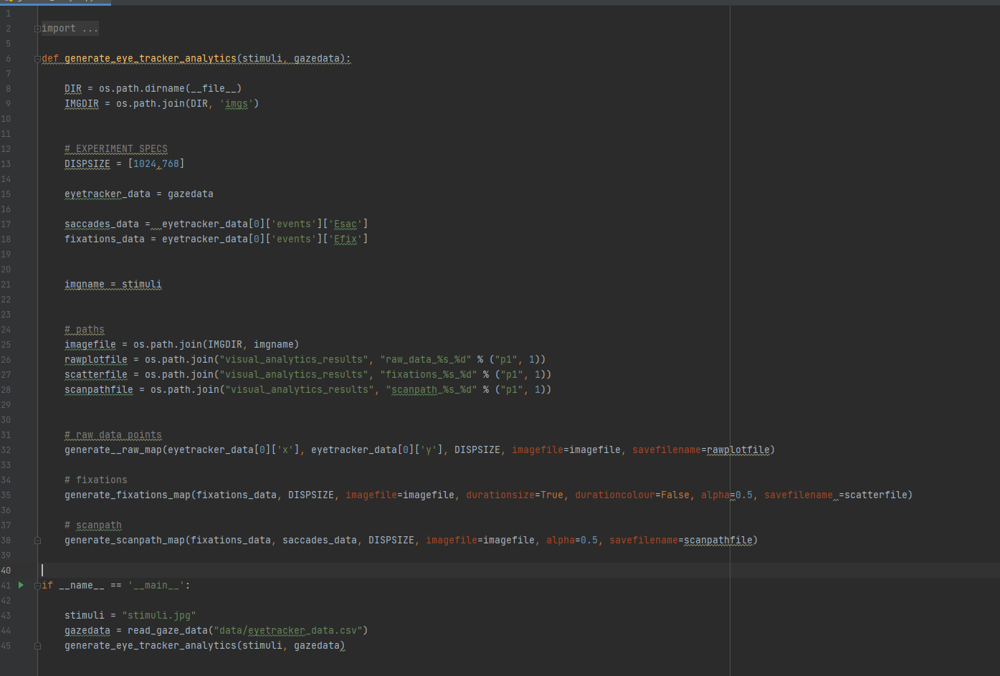



**DESCRIPTION OF TECHNOLOGY**

## Introduction

Eye tracking is a popular, increasingly vital tool in market research. Many leading brands actively utilize eye tracking to assess customer attention to key messages and advertising as well as to evaluate product performance, product and package design, and overall customer experience. Well-established relationship between eye movements and human cognition makes intuitive sense to utilize eye tracking as an experimental method to gain insight into the workings of the mind.

With technological advancements, modern eye trackers have become less intrusive, more affordable, accessible, and experimental sessions have become increasingly comfortable and easier to set up (long gone are the scary “white specks” and head-mounts). Currently, eye tracking is being employed by psychologists, neuroscientists, human factor engineers, marketers, designers, architects - you name it, it’s happening.

With the LeanUX platform Gaze Analysis-Screen-based Eye Tracking Module, you can collect and analyze data in controlled lab environments using Tobii eye Tacker device. The Module allows for analysis of heatmaps metrics like time to first fixation & time spent. This module allows for the recording gaze data and analysis of responses to Image stimuli to provide deeper insights into visual attention.

## Technology Research Contents

The workflow of the gaze analysis based on screen based eye tracker as follows

1. Data Acquisition and Synchronization detects the connected eye tracker with the system.
2. By getting the eye tracker information. It collects the raw signals form eye tracker.
3. Eye tracker firmware needs to adapt the algorithms to the person sitting in front of the tracker.
4. Velocity and acceleration threshold to collect the accurate user position from the system and device.
5. Collect eye tracker metrics data such as Gaze Data, fixation, Time stamps and timing, and Pupil diameter.
6. Visualize the actual data in the form of heat map

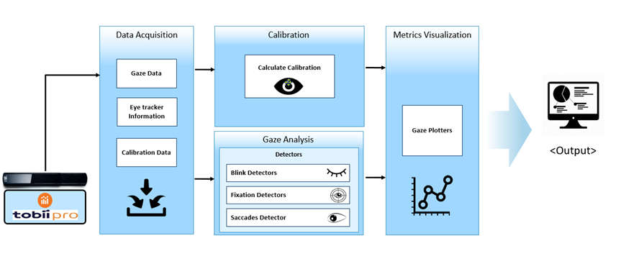

Figure 1. Workflow of Eye-tracking for gaze analysis

## Gaze data and Fixation

Gaze points constitute the basic unit of measure – one gaze point equals one raw sample captured by the eye tracker. The math is easy: If the eye tracker measures 60 times a second, then each gaze point represents a sixtieth of a second (or 16.67 milliseconds).

If a series of gaze points happens to be close in time and range, the resulting gaze cluster denotes a fixation, a period in which our eyes are locked toward a specific object. Typically, the fixation duration is 100 - 300 milliseconds.